BF[1] project: You can choose from the list of projects below (or convince me of a project you feel would be better), but you are required to do the following:

1. Choose only one factor

Temperature

1. Have at least three levels to that one factor.

High, Medium, Low Heat

1. Replicate at least 10 times for each level of a factor
2. Determine the best way to do randomization of your experiment, and describe your randomization process.
3. For the report, please include the following:
   1. Introduction
      1. What is your research question?

Does the temperature of the dryer change how fast a load of laundry is dry?

* + 1. What are the null and alternative hypotheses?

1. **Ho:** **α1 = α2 = α3 =0**
2. **Ha: at least one of the αi is different**
   1. Data Collection
      1. How did you randomize?

I had my wife let our 2-year-old son throw in clothes for 5 seconds.

* + 1. What was the factor(s) and response?

Temperature levels and time, it took till the clothes were dry.

* 1. Factor Structure
     1. Create the factor structure
     2. Describe what design you planned on using

BF

* 1. Descriptive Statistics
     1. Numerical Descriptive Statistics

1. Temperature min Q1 median Q3 max mean sd n missing
2. 1 High 46 62.25 70 80.75 87 69.6 13.74530 10 0
3. 2 Low 82 94.75 103 111.50 118 102.6 11.21705 10 0
4. 3 Medium 65 78.00 89 94.00 95 84.9 11.36711 10 0
   * 1. Graphical Descriptive Statistics

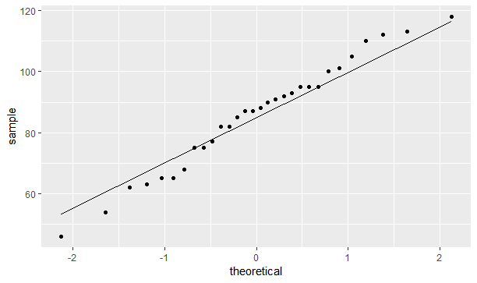

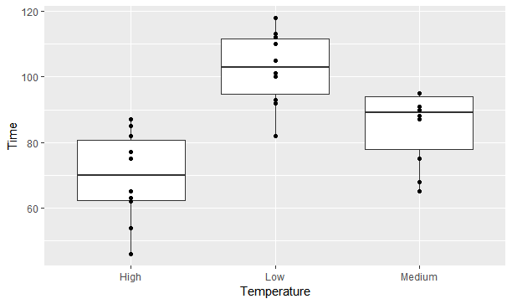

* + 1. “Tell a story” based on what you see in your descriptive statistics

I see that no matter the size of load you have of laundry that the temperature matters on how long it will it to dry. So based on what I saw you should always dry on High heat if you are in a hurry.

* 1. Inferential Statistics
     1. Checking Requirements
     2. ANOVA table, df,SS, MS, F, p-value

1. Df Sum Sq Mean Sq F value Pr(>F)
2. Temperature 2 5455 2727 18.43 8.97e-06 ***
3. Residuals 27 3996 148
4. ---
5. Signif. codes: 0 ‘***’ 0.001 ‘**’ 0.01 ‘*’ 0.05 ‘.’ 0.1 ‘ ’ 1
   * 1. Decision rule (level of significance)

.95

* + 1. Any mean differences or mean treatment combinations that stand out?

Something that stood out to me was that the low heat was quite a bit higher then the other two but the high and medium heat were relatively close when I used a boxplot.

* 1. Conclusion
     1. General Conclusion of your results based on decision rule

That temperature matters when you are drying clothes. This may have more importance then the size of the load.

* + 1. Why do you think you got the results you did?

I think I got the results I did because the hotter the air is in the dryer it will dry clothes more, but I don’t think it is always the best on the clothes.

* + 1. What would you have done differently?

I would have randomized the temperature and controlled the size and the type of clothes that were going in the dryer.

* + 1. Any follow up studies that you would have done?

I would have done big loads like a quilt to see if that is affected as much as clothes.

Different possible projects:

1. factors:

clothes dryer (A,B), temperature setting, load

responses:

time until dryer stops

1. factors:

pan (aluminum, iron), burner on stove, cover for pan (no, yes)

responses:

time to boil water

1. factors:

pack on back (no, yes), footwear (tennis shoes, boots), run (7, 14 flights of steps)

responses:

time required to run up steps and heartbeat at top

1. factors:

width to height ratio of paper sheet, slant angle, dihedral angle, weight added, thickness of paper

responses:

length of flight of paper airplane

1. factors:

brand of rubber band, size, temperature

responses:

length of rubber band before it broke

1. factors:

orientation of football, kick (ordinary, soccer style),steps taken before kick, shoe (soft, hard)

responses:

distance football was kicked

1. factors:

distance from basket type of shot, location on floor

responses:

number of shots made (out of 10) with basketball

1. factors:

temperature, position of glass when pouring soft drink, amount of sugar added

responses:

amount of foam produced when pouring soft drink into glass